Impulse Response measurement
with electroacoustic sources (loudspeakers)

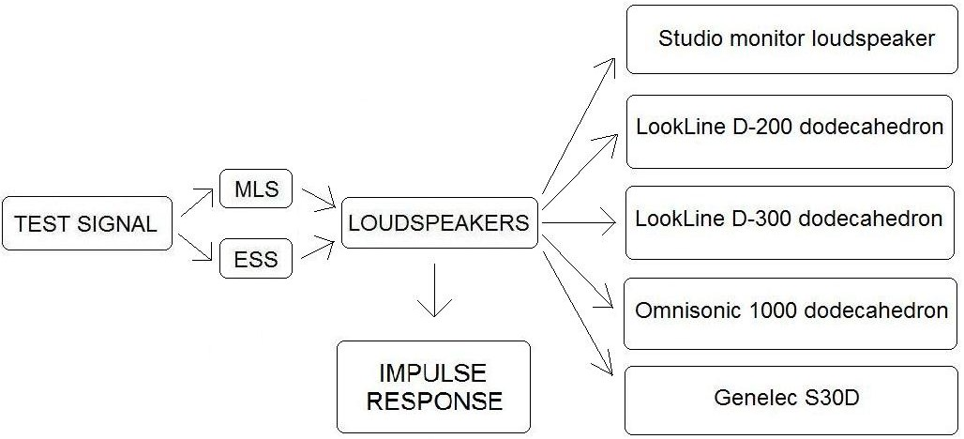

The special test signal
A special test signal x(t) is generated by a computer (for example MLS test signal), which feeds the loudspeaker. The special test signal x(t) is not an impulsive signal because loudspeakers are not good in playing a direct delta pulse, they break if you play a loud pulse on a loudspeaker. We get only a limited power from a loudspeaker, so using a true pulse is not the optimal way of employing a loudspeaker. We usually play a long signal that spreads energy over time. The signal reverberates in the room from the loudspeaker while a microphone records the room’s response. Thus we have an output signal y(t) but it is not the impulse response h(t) because x(t) is not the impulse signal. x(t) is a continuous signal (it can even be noise). We can determine h(t) if we know x(t) and y(t) by a deconvolution.

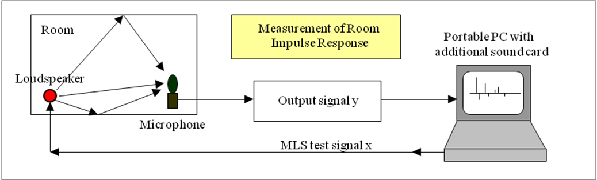
-Fig.01-

Loudspeakers
We have seen the characteristics of different kind of loudspeakers: studio monitor loudspeaker, LookLine D-200 dodecahedron, LookLine D-300 dodecahedron, Omnisonic 1000 dodecahedron and Genelec S30D. The normal studio monitor loudspeaker placed on the desk, has a good quality. It cannot be considered a professional loudspeaker for acoustical measurement because it is a directive source (and not omnidirectional). According to the ISO 3382 standard the typical loudspeaker used to create an omnidirectional source is the dodecahedron. The LookLine D-200 dodecahedron in Fig.02 it is not just a dodecahedron because the base contains both the power amplifier and a subwoofer that radiates very low frequencies, while the mid-high frequencies are radiated by the sphere with the twelve loudspeakers. This kind of source generates the blue line which indicates the frequency response visible in Fig.03.

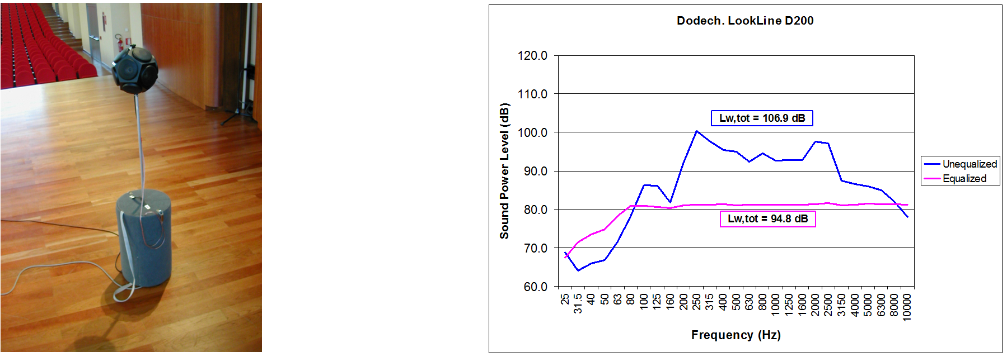
-Fig.02- -Fig.03-

If we do not apply digital equalization the distribution is uneven, which is not good. We should have a flat response. If we apply digital equalization we get the flat pink line. The consequence of getting a flat power spectrum is that we loose 12dB. The radiation efficiency of this kind of loudspeaker is very poor because it irradiates only 1 acoustical Watt with an electrical power which can be 200W. The radiation efficiency of normal loudspeakers is lower than one percent. The loss of decibels can be really a trouble, so we need some tricks to improve signal to noise ratio, using special test signal, not just like white noise. If we use a normal test signal, like white noise, the signal to noise ratio will be bad.

Directivity
We think that a spherical source radiates perfectly at every frequency, but this actually is not true. In fact the LookLine D-200 dodecahedron in the Fig.04 does not radiate perfectly the sound at every frequency: in effect it is uniform up to 2kHz but from 4kHz upwards it becomes distorted. The LookLine D-300 dodecahedron is bigger than th LookLine D-200 and already at 2kHz we can see the deterioration in radiation - Fig.05.
The smaller the loudspeaker, the more omnidirectional it is. The bigger the loudspeaker, the more directive it will be, so not omnidirectional. Omnisonic 1000 dodecahedron is a new type of loudspeaker, it has a particular shape like a flower. This loudspeaker makes sound radiated by different units to merge together, recreating a continuous spherical waveform. The American company who produces Omnisonic 1000 claims that its shape makes the radiation omidirectional at every frequency, but this is not the case, see Fig.06. Genelec S30D is not an omidirectional source, as shown in Fig.07. It can be used to reproduce real world sounds from some sources such as horn instruments, brass instruments and human voices.

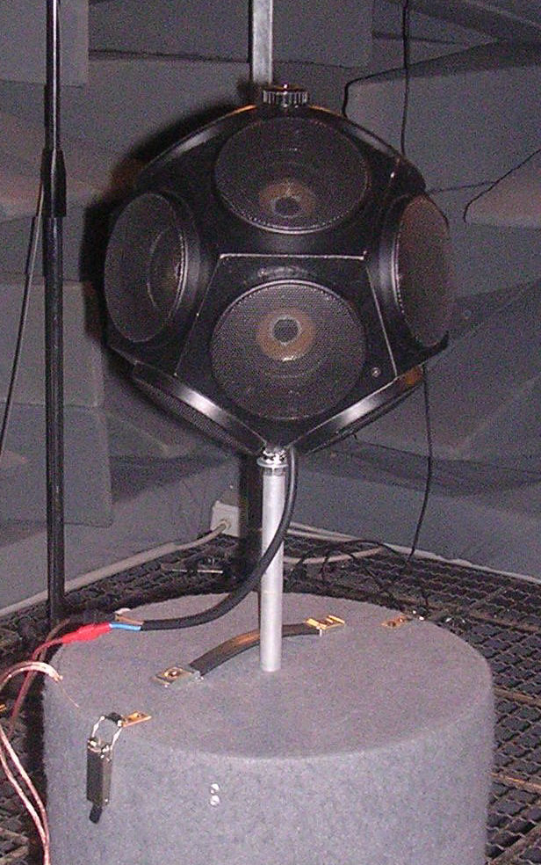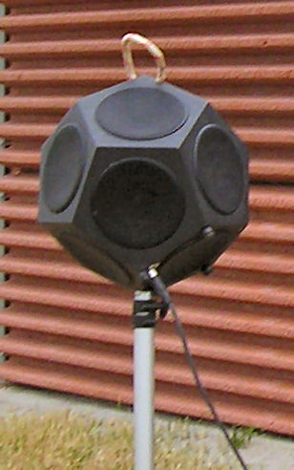
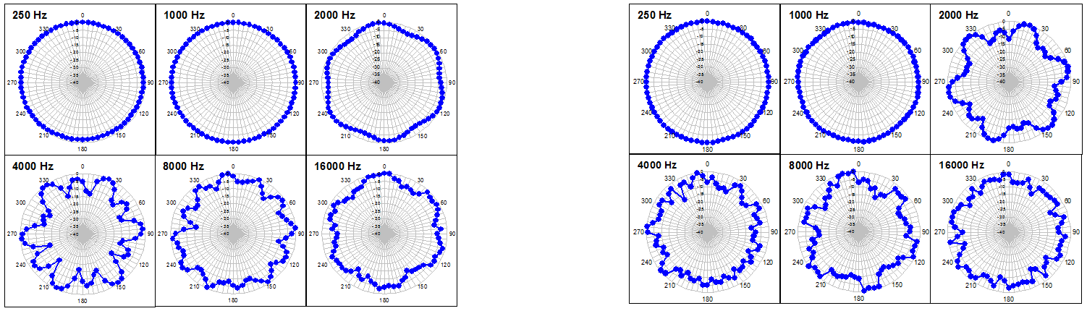
-Fig.04- -Fig.05-

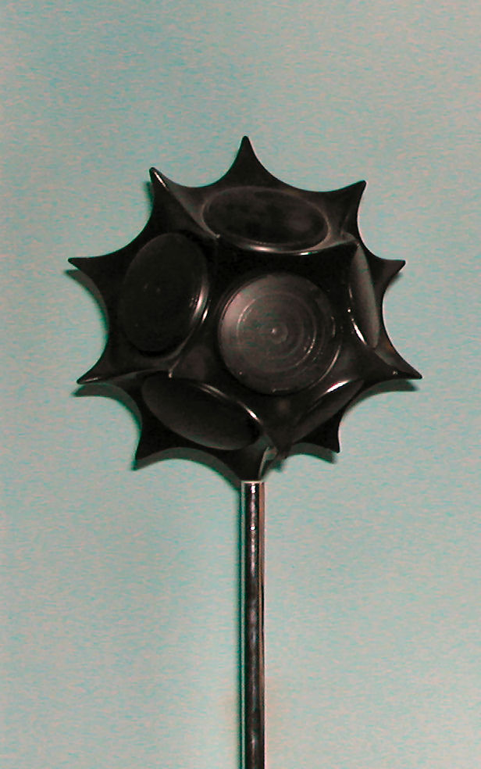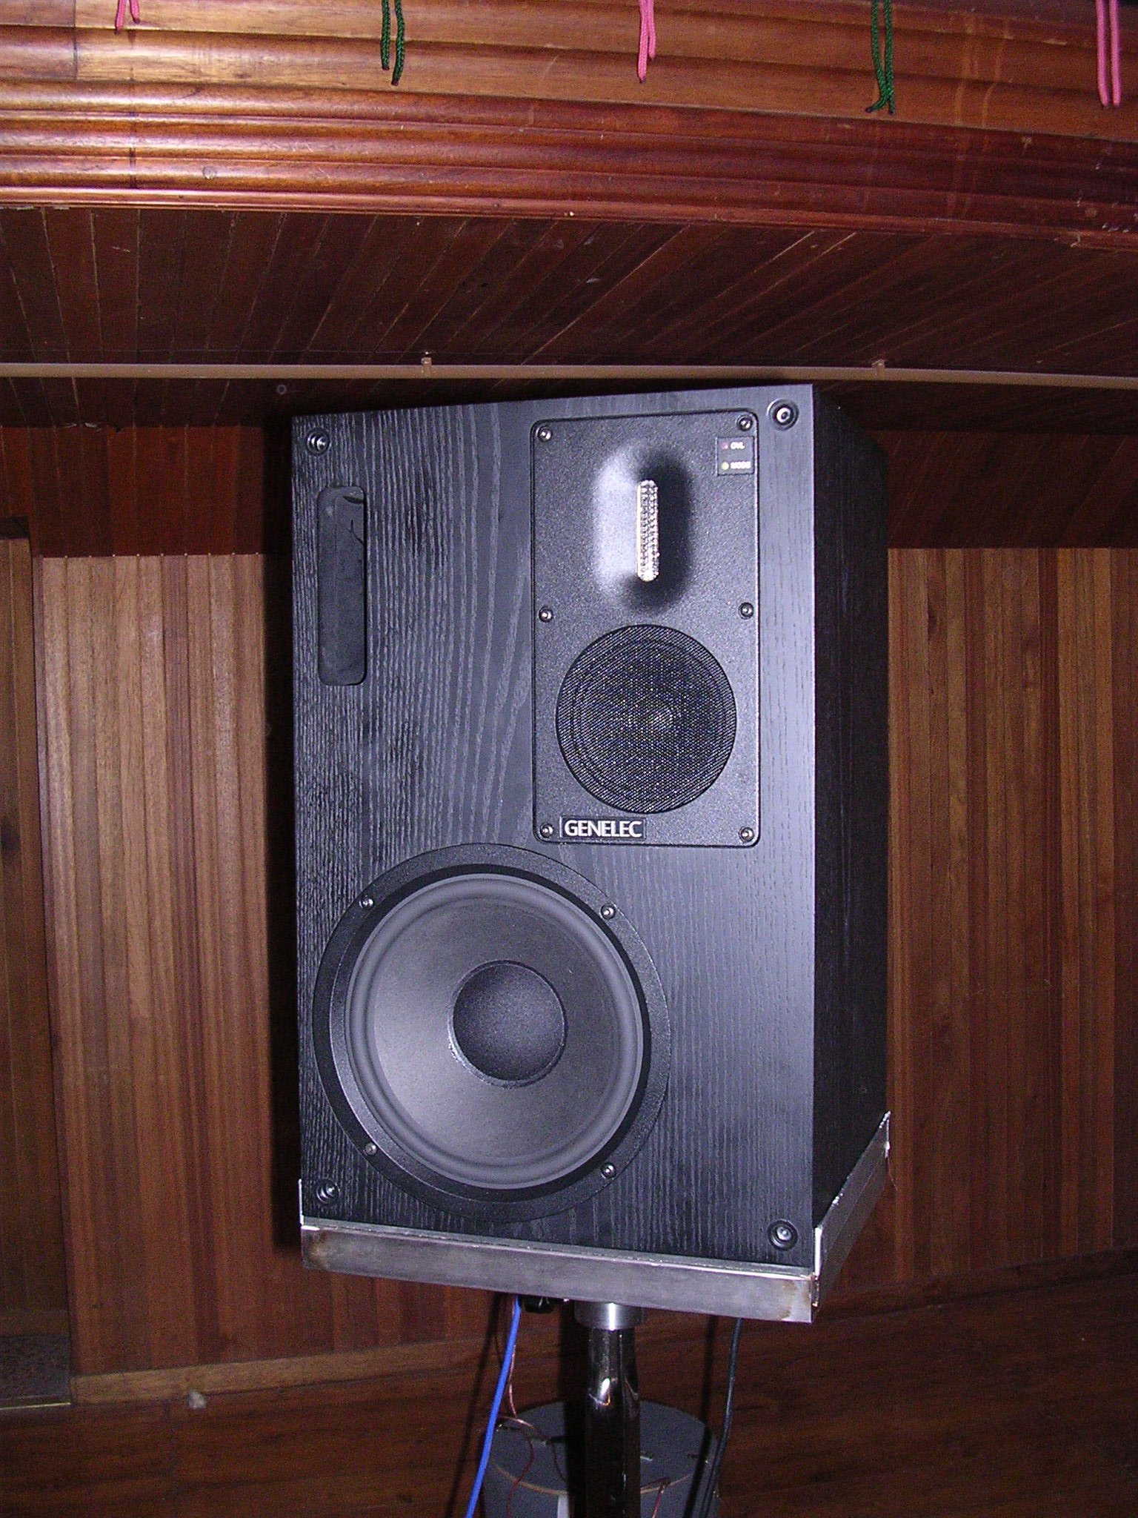
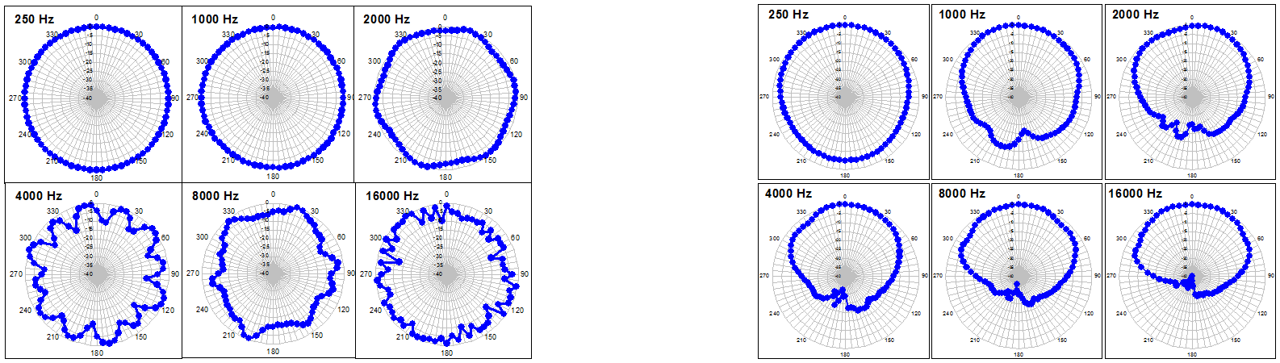
-Fig.06- -Fig.07-
Measurement process
The measurement process, outlined in Fig.08, starts when the test signal x(t) passes through a loudspeaker, which in general is not a linear device. There is always some kind of distortion. It generates a distorted signal w(t) that reverberates inside the room, where the reverberation process occurs; reverberation is usually a perfectly linear process. Then we also capture the environmental noise, n(t), but of course we do not want this noise and we do not want the bad effects caused that are caused by the not linearity effects of the loudspeaker.
When measuring with a loudspeaker, the S/N ratio is always a problem, because the loudspeaker is not as powerful as the firecracker or the balloon. The radiation of the firecracker is 30dB more powerful than a typical loudspeaker.
If we try to squeeze out more power from the loudspeaker, driving it at an higher voltage, we boost its nonlinearities.
An optimal deconvolution technique has hence two goals:

  - To improve the signal/noise ratio.

  - To reject the not linear effect of the loudspeaker.

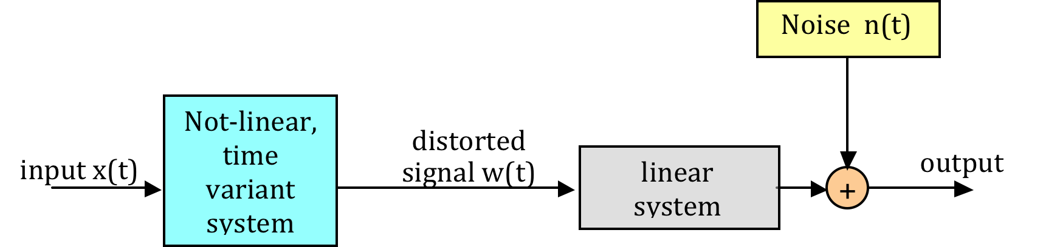

-Fig.08-

Test signals
In time different types of test signals have been developed, providing good immunity to background noise and easy deconvolution of the impulse response:
  - MLS (Maximum Length Sequence, pseudo-random white noise).
  - TDS (Time Delay Spectrometry, which is a linear sine sweep, also known in Japan as “stretched pulse” and in Europe as “chirp”)
  - ESS (Exponential Sine Sweep) The most modern one invented by Prof. Farina.
Each of these test signals can be employed with different deconvolution techniques, resulting in a number of “different” measurement methods. Today, the preferred choice is the ESS with non-circular deconvolution.

Short story of impulse response measurements
Before 1989 you could only measure the impulse response with a pistol or a balloon. The MLS signal was the first test signal invented in 1989, where an impulse response could be measured electroacoustically. It is generated by a long board inserted in a big computer and the board captured the sound from only one channel. MLSSA was the first apparatus for measuring impulse responses with MLS. A more modern version of MLSSA signal was the CLIO system, invented in Florence. Techron TEF 10 was the first apparatus for measuring impulse responses with TDS and it supported lso MLS. We now use a normal PC with a good esternal Firewire soundcard, where we connet our microphone, loudspeaker, and we can play our test signal. It is considerably more powerful, with 8-10 input channels available, and it works up to 24bit, 192kHz. Some of the Adobe Audition Plugins called Aurora were developed here in Parma. It was the first measurement system based on standard sound cards and employing the Exponential Sine Sweep method. It also works with traditional TDS and MLS methods, so the comparison can be made employing exactly the same hardware.

MLS (Maximum Length Sequence)
The MLS signal is a periodic binary signal (one or zero), as shown in Fig.09, obtained with a suitable shift-register, shown in Fig.10, configured for maximum length of the period (L).

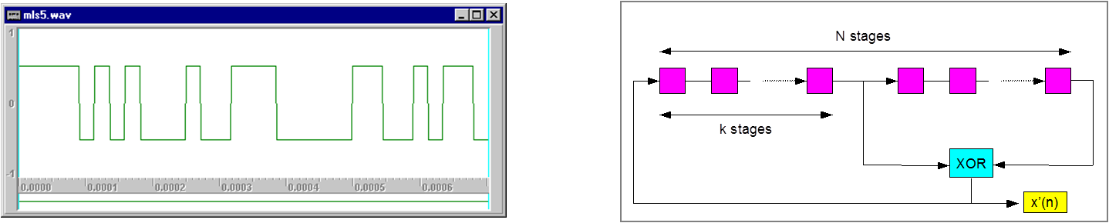
-Fig.09- -Fig.10-

$$L=2^{N}−1$$

The deconvolution is performed with the Hadamard matrix, obtained by L permutations of the original MLS sequence.

$$\tilde{M}(i,j)=m\left[\left(i+j−2\right)\text{mod}L\right]−1$$

The result is the required impulse response h(i), if the system is linear and time-invariant.

$$h=\frac{1}{L+1}⋅\tilde{M}⊗y$$

The Hadamard transform is very efficient computationally because it is fast, but does not well in a non linear system. Another advantage of the Hadamard transform is that the signal to noise ratio improves a lot with MLS method. The two big advantages are:
  - Little computational load for performing the deconvolution.
  - Very good improvement in signal to noise ratio.
The main disadvantage of MLS are the bad artifacts due to non linearity of the loudspeakers, and its sensitivity to clock mismatch between player and recorder.

MLS measurement procedure
We have seen an example of measurement of impulse response in a church with MLS signal, the test signal was played and the system response was recorded simultaneously. The signal to noise ratio was quite good.
However in the last part of the measurement there were artifacts, sounding like echoes, as visible in fig. 11. The artifacts are due to the non-linearities of the loudspeaker, which are wrapped inside the impulse response due to the “circular” nature of the Hadamard transform.

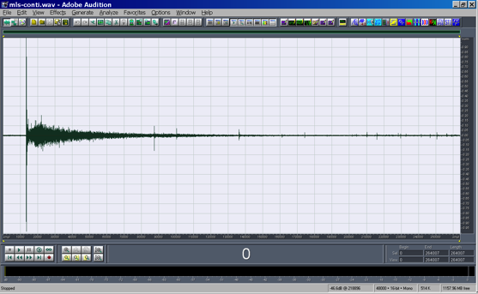
-Fig.11-

Exponential Sine Sweep method
x(t) is a band-limited sinusoidal sweep signal, where frequency is varied exponentially with time, starting at f₁ and ending at f₂.

$$x(t)=\text{sin}\left[\frac{2⋅π⋅T⋅f_{1}}{\text{ln}\left(\frac{f_{2}}{f_{1}}\right)}⋅\left(e^{\frac{t}{T}⋅\text{ln}\left(\frac{f_{2}}{f_{1}}\right)}−1\right)\right]$$

The instantaneous frequency of the test signal x(t) does not increase lineary, but it is increases exponentialy with time, as shown in Fig.11. When we play it through a loudspeaker, there will be some distortion. At every instant the not linear loudspeakers not only radiates the signal at the frequency of the test signal, it will also radiate at 2kHz, 3kHz, 4kHz etc., as shown in Fig.12. This phenomenon is called harmonic distortion and causes the artifacts of MLS.

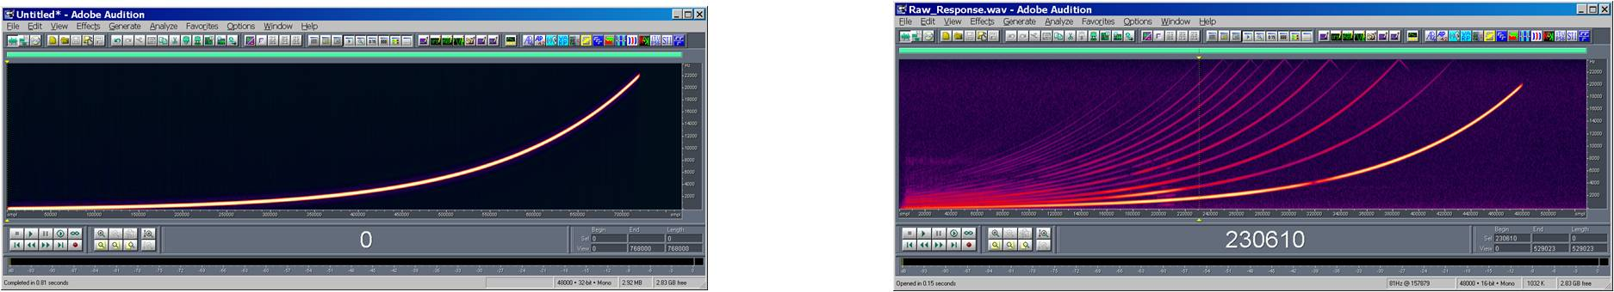
-Fig.11- -Fig.12-

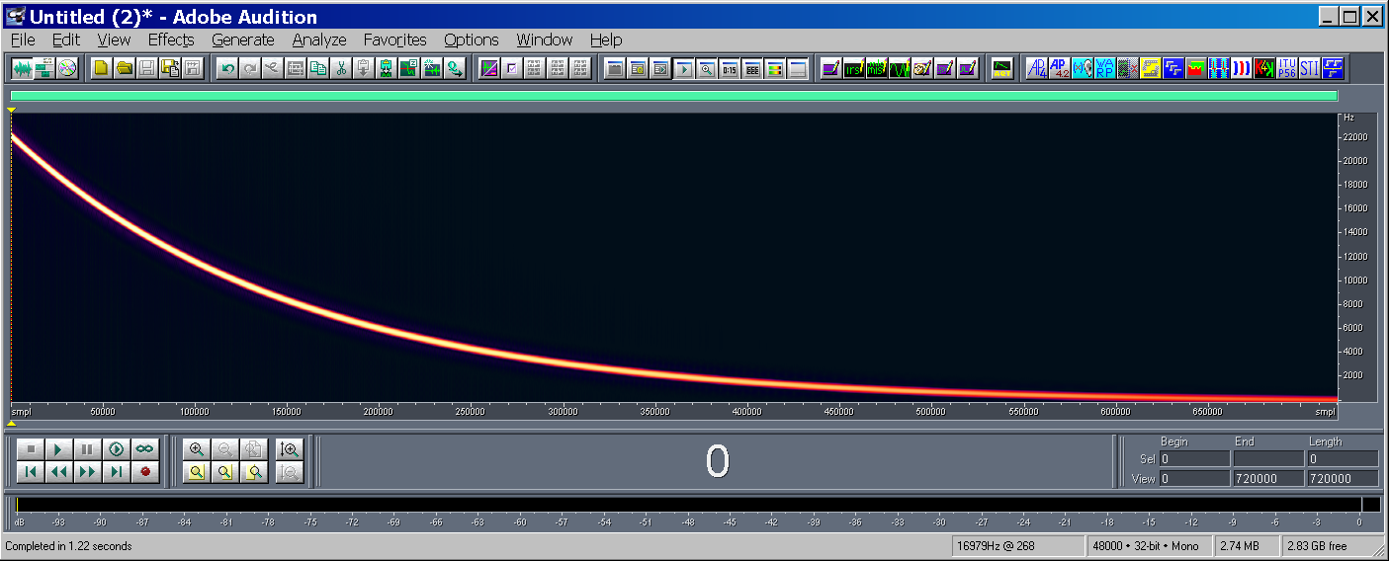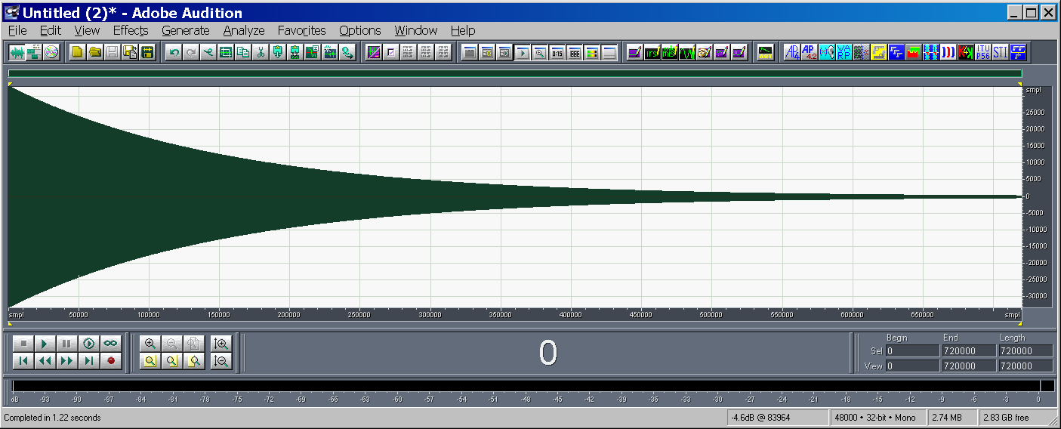
-Fig.13-

To get back the impulse response h(t) we have to define an inverse sweep signal z(t), shown in Fig.13. It is the time reversal of the original sweep signal played backward from high frequency to low frequency. Also the amplitude has been changed, because the spectrum of the ESS was not white, as shown in Fig.14, it was pink. By applying the amplitude modulation we have reversed the slope of the spectrum of the inverse filter z(t), which is shown in Fig.14.

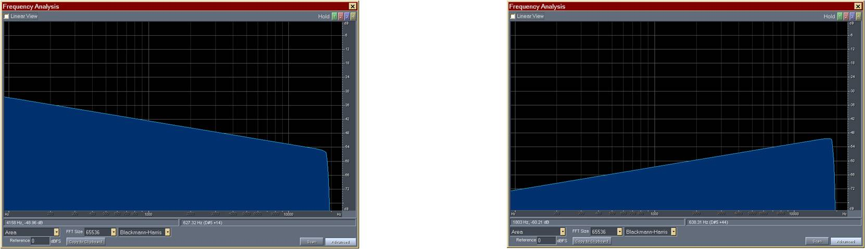
-Fig.14- -Fig.15-

The inverse sweep signal is very loud at high frequency and reduces proportionally towards low frequency. When we convolve the test signal x(t) with inverse filter z(t) the result is flat (in frequency domain) and an almost perfect Dirac’s Delta function in time domain.
A measurement made with ESS profits of the pink spectrum of the test signal, and this gives two advantages:
  - Much better signal to noise ratio at a low frequency.
  - The energy at high frequency is weak, so it does not destroy the tweeter. The tweeter is delicate, the woofer is not.

Deconvolution
After recording the output signal y(t), we get a signal containing the linear response but also the distorted response at second order, third order etc., as shown in Fig.16. Convolving the recorded signal y(t) and the inverse filter z(t), the result of convolution is the rotation of the sonogram because high frequency will not be delayed and low frequency will be delayed. So the linear response, which was stretched over time, packs at a precise time in the rotated frequency-time plane, as shown in Fig.17. After the convolution the last impulse (on the right) is the wanted impulse response (the linear part of the response of our system).

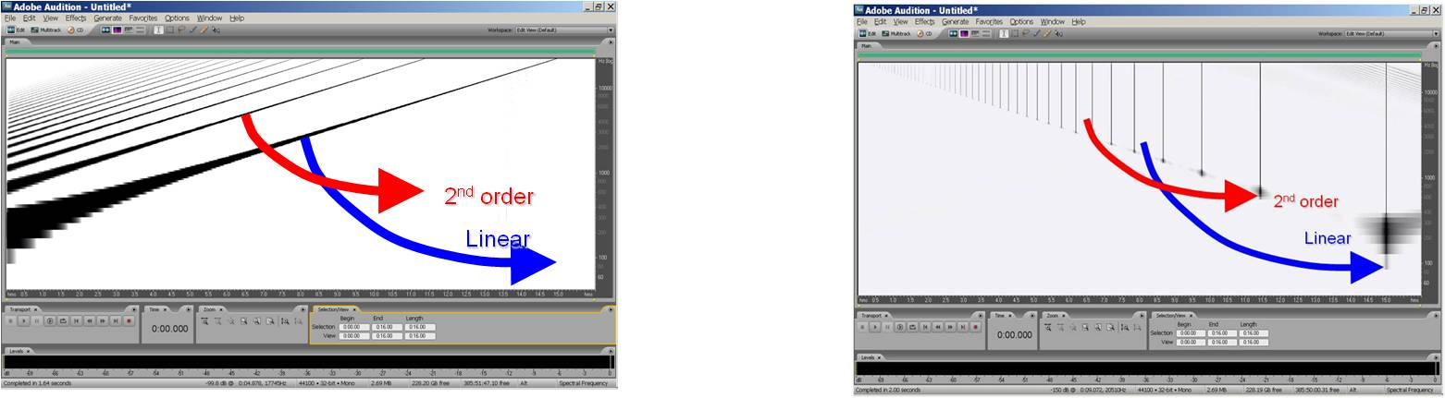
-Fig.16- -Fig.17-

Result of convolution
Coming back from the sonogram in Fig.17 to the normal waveform shown in Fig. 18, there are a number of impulse responses. The last impulse response on the right is the linear impulse response which we want to measure. All the other peaks are the distortion products. These peaks contaminate the impulse response, so we must get rid of them to avoid any contamination with the non linear part of the transfer function of the system. Non-linearity of the loudspeakers is no longer a problem. This is the big advantage of the exponential sine sweep against the MLS. The loudspeaker can be pushed in heavy distortion and that will not be a problem because the distortion is separated in time domain, coming before the linear impulse response. So at this point we can see only the linear impulse response, without any artifacts in the tail, as shown in Fig.18. Considering the same example used for the MLS signal in the church, using the ESS has the following advantages:
  - Very good signal to noise ratio, around 20dB better than the MLS signal with the same loudspeaker and the same microphone.
  - Any problem of nonlinearity was removed.

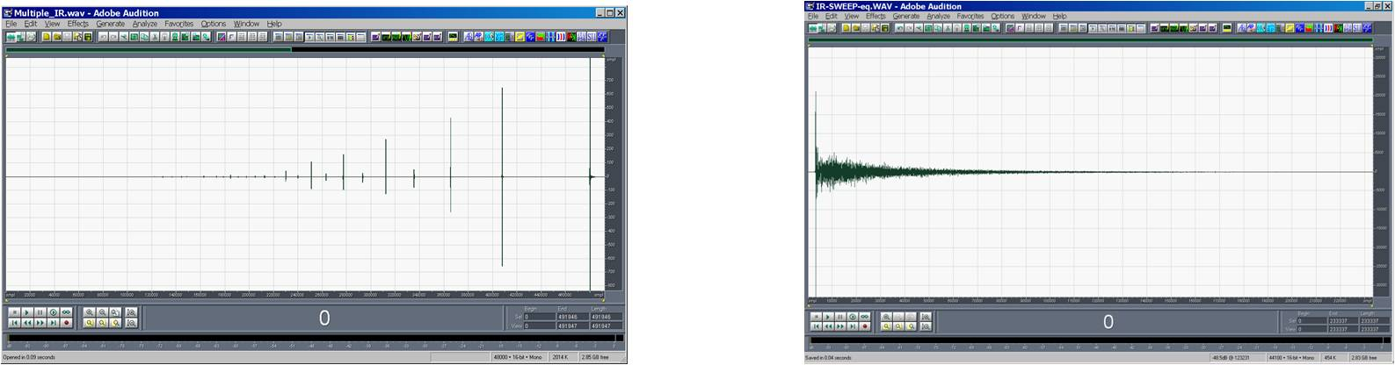
-Fig.17- -Fig.18-

