Sound Pressure Measurements

Lesson Index – Topic: Sound Pressure Measurements

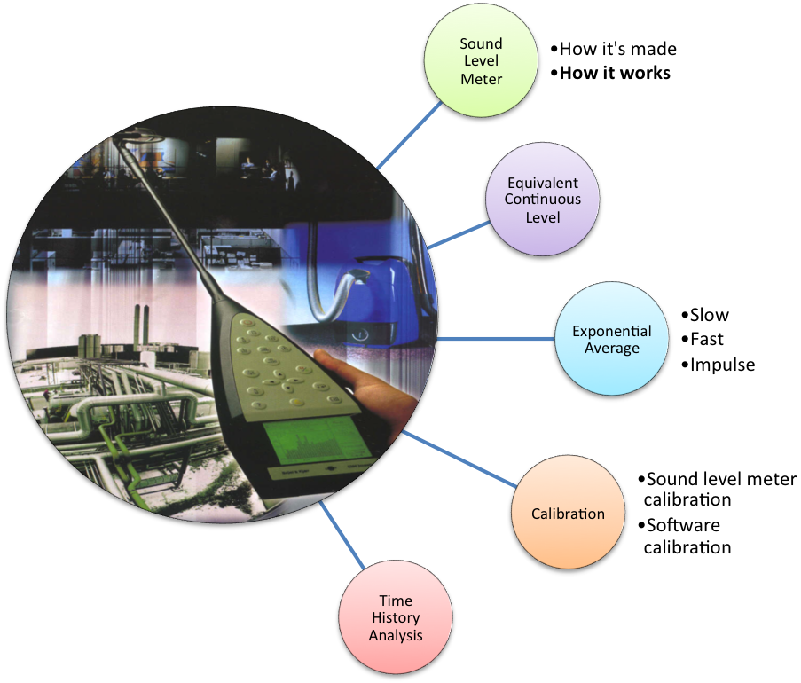

The Sound Level Meter

A sound level meter (SLM) is an instrument which measures sound pressure level. The current international standard that specifies sound level meter functionality and performance is the IEC 61672:2003.
The latest sound level meters are bottle-shaped and high-tech instruments, and most of them have the same parts. Figure 1 shows the general structure of a sound level meter.

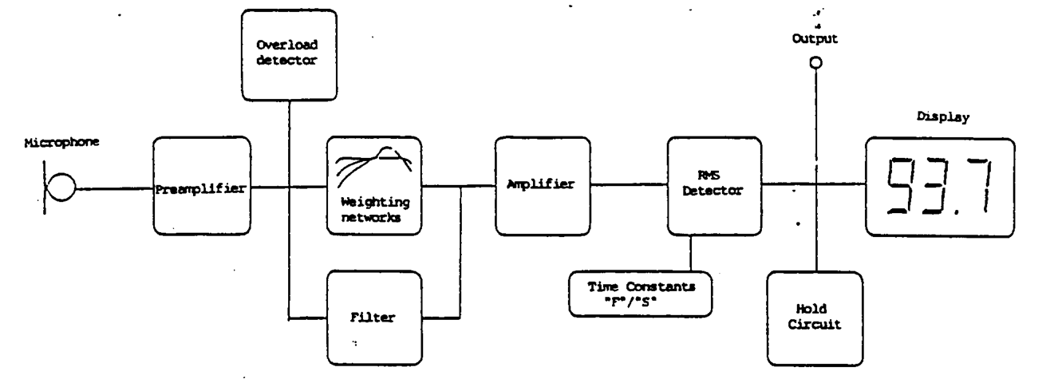
Figure 1 – Sound pressure level structure

- Microphone: even the cheapest sound level meter mounts a condenser microphone, also called capacitor microphone, because this is the only type of microphone able to perceive pressure variations perfectly. Condenser, in fact, tend to be very sensitive and responsive, making these microphone well-suited in capturing subtle nuances in a sound.

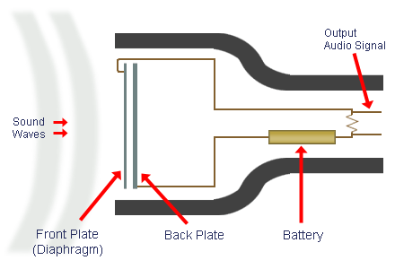
Figure 2 - Condenser microphone

- Preamplifier: this block has the function of increasing, or decreasing, the gain of the system, in order to set the range of values within ones at which sound pressure level works. In fact, sound level meters generally have a limited range of measurement values. The measurement can be considered valid only if resulting value rests within range values. because of this, users must be able to change these values, and they can do this using some keys, placed in front of the instrument, making instrument more or less sensible, in case the user is measuring low, or high, level sound. Two wrong cases can occur:
- the resulting level is too low (sound level meter is under range);
- the resulting level is too high (sound level meter is overloaded).
In this cases, users have to change full scale value and repeat the measurement.

- Frequency weighting filter: in front of sound level meter, we can generally find keys which allow to choose which frequency weighting use in sound analysis. We will discuss only about A-weighting and C-weighting.

- AC output: can be used to register analyzed sounds.

- Overload detector: if the resulting sound pressure level is out of the valid range, this detector tells to the user, trough the display, that full scale value has to be changed.

- RMS detector: this is the main block. It performs the most important function, in fact computes the mean sound pressure level, as shown in the following formula:

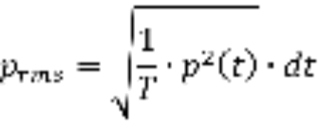

(1)
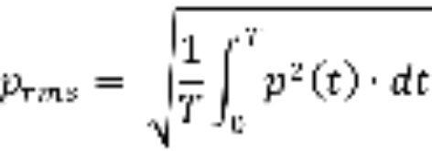

This value is now in Pascal and it’s converted in decibel (dB), using this formula:

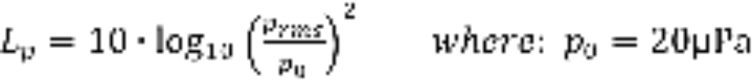 (2)
The sound level meter measures only a pressure, the sound pressure level, and it’s displayed in dB.

- Display: shows information trough charts and number, providing results in both analog and numerical forms, making the user known sound pressure level at all frequencies.

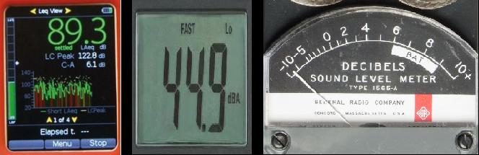
Figure 3 - Chart, numerical, pointer displays
Now we have seen how is generally structured a sound level meter. In the next part we will discuss in detail on how RMS block works.

The Equivalent Continuous Level

The equivalent continuous level is the average effective value of sound pressure, computed over a time interval T, and it’s defined as:

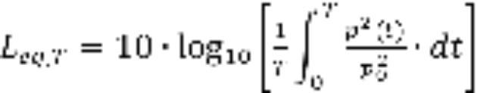 (3)

This is an average value, and this is easier to understand looking at the Figure 2. Rectangle’s area is equal to the one subtended by the instant sound pressure.

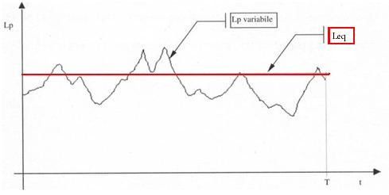
Figure 4 – Equivalent sound level

This value is performed trough a linear integral so it’s very reliable. Unfortunately, if T is large enough, only the most advanced and expensive instrument can perform such a precise measurement. Because of this, the measurement technique we have just examined is used only in labs or in precision measurement. The cheapest sound level meters cannot perform a linear integral, so they computes an average pressure level trough an exponential integral.

Exponential Average: Slow, Fast, Impulse

Electronic circuits able to compute linear integral must be very complex and expensive. Instead an exponential integral can be performed by a very simple and cheap circuit: a resistance and a condenser. Because of that, even the cheapest sound level meter can be used to run a sound level analysis, with good precision.
In this case, the root mean square (RMS) value is computed by the following formula:

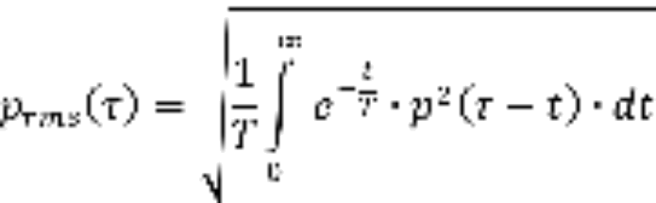

(4)

The main difference between previous and current approach is that, if before the same weight was given to all the signal along period T, now the importance of perceived sound decrease, more or less quickly, depending on the chosen value for t.

Setting | Slow | Fast | Impulse
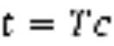 | 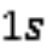 | 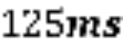 | 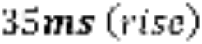  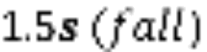

Figure 5 shows the way slow setting determines progressive weight loss for oldest sounds.

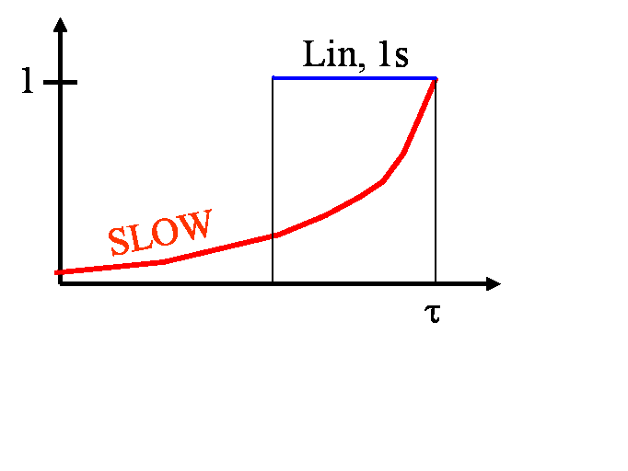
Figure 5 - Slow

Fast setting is really useful : in fact it generates sound charts corresponding to human hear perception. This is possible because the human auditory system has about 100 ms of latency, similar to fast value (125 ms). In order to obtain such a result, weighting frequency filter has to be set on A-weighting.
Impulse setting, instead, is an oldest instrument’s legacy. In fact, as we seen in Figure 3, they displayed information by a moving pointer. A very intense and quick sound results in a powerful and an hard to see movement of the pointer. Because of this, impulse setting was introduced: in fact, it force the pointer to raise very quickly but it slows the fall, helping users in seeing results.
Nowadays, impulse setting survives for a different reason. Impulse sounds are annoying, and a good sound technician must consider them, so they have to be detectable. Impulse sounds can be detected using the impulse setting. An impulse sound can be detected by a sound analysis software, performing both slow and impulse analysis, and verifying this simple inequation:

(5)

If the previous inequation is correct, then we know that an impulse sound was occurred. Law establishes that, in this case, the equivalent sound level has to be increased by 3 dB, in order to consider the occurrence of the impulsive sound.

Calibration

In chain made by components used in sound measurements, there are many parts which can change between two different measurements. For example if we use the same sound level meter but not the same microphone, we have to re-calibrate the entire analysis system in order to obtain a reliable result.
We did not mention it before, but a sound analysis can be done even with a software, for example Audacity of other professional programs. Even in that case the chain of components may change: in fact it’s typically composed by a microphone, a sound-card and a computer equipped with a sound analysis software. If only one of these components changes we have to perform a new calibration.
Calibration, in both cases, can be done with a single, expensive, instrument: a calibrator. This instrument emits a single-frequency, pure, tone. We can connect it to the microphone to perform the calibration of entire chain, as shown in Figure 6.

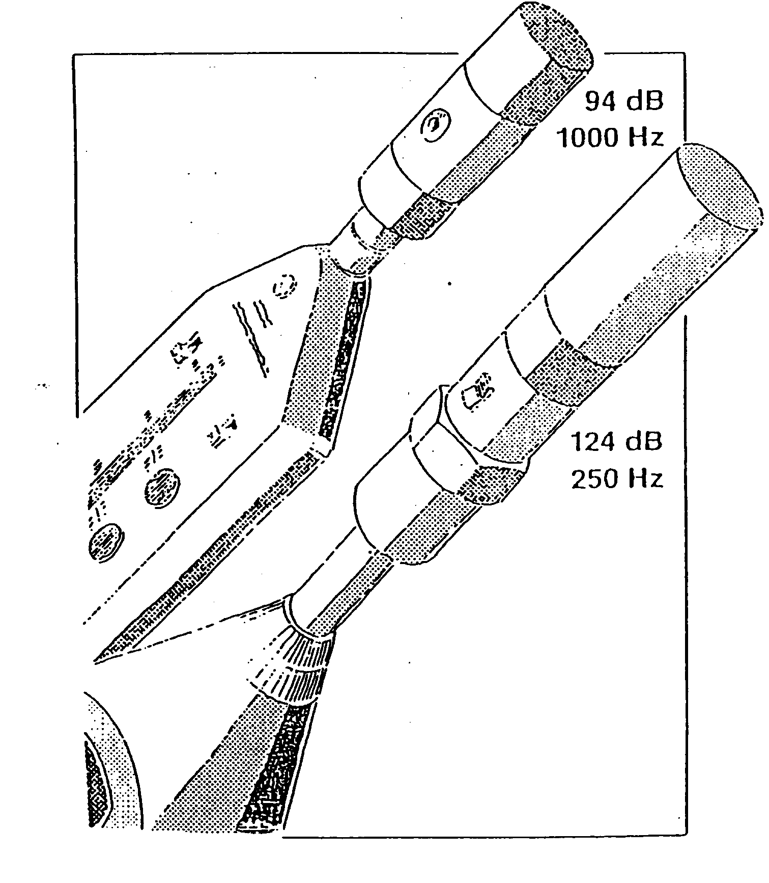
Figure 6 – Calibration

When the calibrator is connected, our sound system analysis perceives the pure tone emitted by the calibrator. Now, given the sound emitted, we can check if the system is working correctly. In fact, theory tells that a pure tone issued with a frequency of 1000 Hz generates a sound level pressure of 94 (dB), that can be seen in Figure 6. So, if our analysis system detects a different sound level pressure, we have to set it until the correct value is displayed.
Both sound level meters and analysis software need for calibration, but setting is different:
- Sound level meter is commonly set through a screw;
- Software is set changing its own options, forcing it to align to the gain of analysis system.

Time History Analysis

Time History Analysis is a software plugged in many analysis software and can be useful for many sound analysis steps. For example, can be helpful in calibration of entire system or in checking calibration. Its main function, however, is showing analysis results. In his report user can see the equivalent sound level pressure of analyzed sound, its fluctuations over time, and so on.
The equivalent sound level pressure chart form is strongly affected by time constant (slow, fast, impulse) chosen. Figure 7 shows how could appear a sound chart if fast constant is selected. Setting such a constant results in generating a sound graph similar to human perception of the sound.
Slow constant makes the chart more flat, reducing ripples. Impulse, instead, highlights rises and smoothes descents.

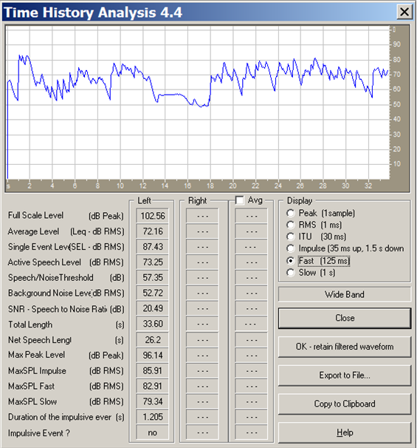
Figure 7 - Time History Analysis

It’s worth to point out that Time History Analysis can also detect impulsive events. As we can see in Figure 7, if Formula 5 is verified, an impulsive event is detected and it will be reported in the last line.

